America's Boating Channel™
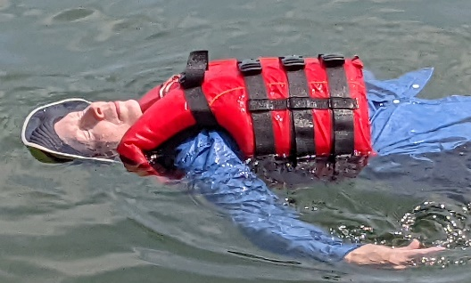
Promoting National Safe Boating Week, May 20-26, 2023
Recreational boating and water activities are enjoyed by millions of Americans each year. Boating safety advocates recommend all boaters and passengers have a life jacket and always wear it while boating. Regardless of your age or experience level, the data shows that life jackets save lives.
But a life jacket can only save your life if it’s used correctly. Always keep life jackets clean and neatly stowed when not in use. Proper care of life jackets ensures that they'll work when they're needed and extends their useful life. Plus, fresh clean life jackets are more attractive to wear and desirable for people to use while underway on your boat.
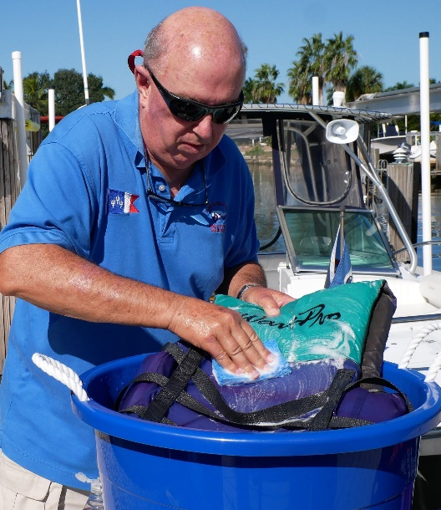
In-the-water buoyancy testing should be conducted at the beginning of every season. Foam deteriorates over time, so test to ensure that your life jacket keeps your mouth out of the water. A serviceable life jacket should keep you afloat for several hours, with all hardware and straps firmly attached and in working order.
Videos are available that offer an overview of the importance of wearing and caring for your life jacket. America’s Boating Channel produced these videos to help viewers learn it only makes sense to treat your life jacket as though your life depends on it.
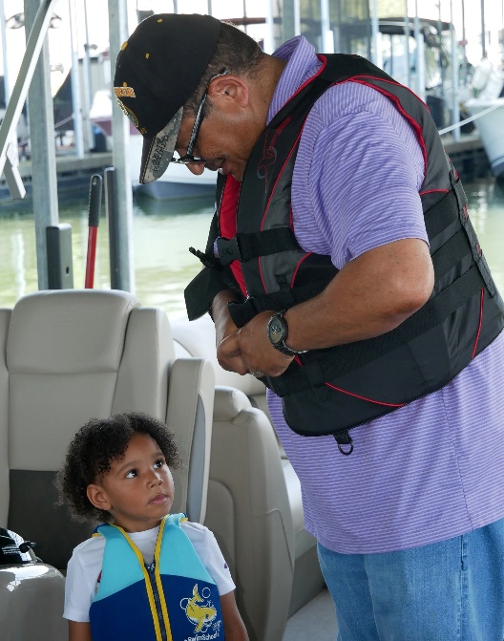
Watching videos like "Life Jacket Care" (https://youtu.be/iEofd6mUwN4) is an excellent way to understand how to properly care for your life jacket. America’s Boating Channel also produced a sequel entitled “Life Jacket Wear” (https://youtu.be/FgFLNGIbFxo). It shows how recreational boaters can ensure serviceability and extend the useful life of life jackets. Viewers also learn about special considerations for inflatable and foam-filled jackets. Also featured are tips regarding life jacket replacement. You can follow the above links or visit https://www.youtube.com/@AmericasBoatingChannel to find these and other safe boating videos, which are an excellent tool to help recruit participants to our educational program and to membership. Invite your friends and neighbors to watch, like and subscribe to America’s Boating Channel to introduce them to what our organization has to offer.
In addition to YouTube, these professionally produced high-definition safe boating and boater education videos are available via the America's Boating Channel on-demand app on Roku or FireTV. America’s Boating Channel™ is produced by the United States Power Squadrons® (USPS) under a grant from the Sport Fish Restoration and Boating Trust Fund administered by the U.S. Coast Guard.

