Proper care of life jackets ensures they will work when needed. Plus, fresh clean life jackets are more attractive to wear and desirable for people to use while underway on your boat. **Videos are available that offer an overview of the importance of wearing and caring for your life jacket. America’s Boating ChannelTM produced these videos to help viewers learn that it only makes sense to treat your life jacket as though your life depends on it.**

Watching videos like ["Life Jacket Care"](https://youtu.be/iEofd6mUwN4) (<https://youtu.be/iEofd6mUwN4>) is an excellent way to understand how to properly care for your life jacket. Invite your friends and neighbors to watch, like and subscribe to [America’s Boating Channel on YouTube](https://www.youtube.com/@AmericasBoatingChannel) as a fun and educational introduction to what our organization has to offer. This video and more also are available via America's Boating Channel on-demand app on Roku or FireTV.

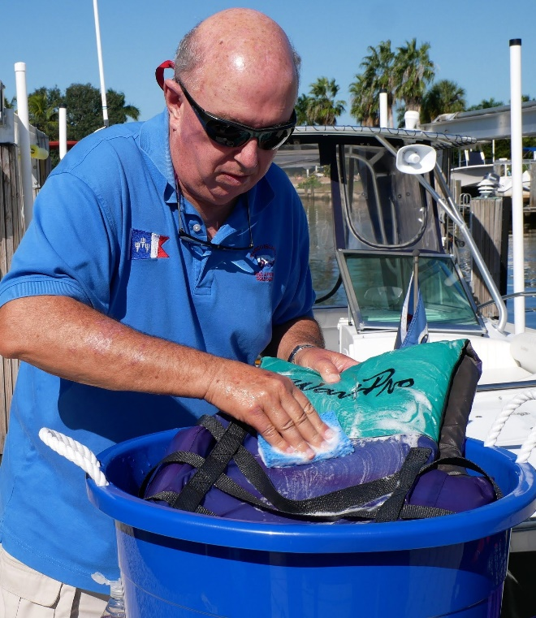

**Life Jacket Care**